**Final Project Directions & Rubric**

*The mentors and instructors will be there to help you with some issues but this is a project you must do on your own with little support.*

**Capstone Project Requirements**

* Build a Project using six of each from the following lists:
  + Languages and Technologies (six from this list)
    - Python
    - React
    - GitHub
    - Ajax / Fetch / Axios
    - JSON
    - CSS or SCSS
    - Data Types
    - SQL or NoSQL
    - JavaScript
    - HTML
    - UML
    - UI/UX
  + Methodologies / Best Practices (six from this list)
    - Control Structures
    - Algorithms
    - Quality
    - Project Management
    - Problem Solving
    - Agile
    - Object-Oriented Programming
    - Functional Programming
    - Software Engineering
    - Behavior Driven Development
    - Test-Driven Development
    - API’s
  + You must include one language/feature/framework that you did not learn in the course.  For example:  Search Bars, Payment Processing, Picture Carousel, etc… **Be Creative**
* You must build a Microservice App Process
  + The backend is Python, Ruby or any other backend language.
  + The back end must be connected to the Front-End via API.
* The App must be mobile responsive
  + Unless you can provide a good reason why it cannot be.  For example: Browser-based video game
* Hosted on any hosting service
* It is permissible to use tutorials, **The tutorial cannot make up more than 40% of the FInal Capstone Project.**

**List of Approved Projects**

*The following list is available to help you come up with ideas.  You can build anything as long as it follows the guidelines listed above.*

* **eCommerce** – Build an online shop. User Story: A user can select from a set of products and walk through the full purchase process.
* **Modern Blog** – Building a blog that allows for Omniauth and Elasticsearch. User Story: A user can create a blog account by logging in with one or more social accounts (Facebook, Twitter, GitHub, etc.) User Story: Visitors can search through content via Elasticsearch, including an auto-complete component.
* **Chat App –**Build the key features utilized for chat functionality. User Story: A user can create a group chat room and post messages in the group. User Story: A message is only shown in the group it has been posted in.
* **LMS** – Rebuild DevCamp. User Story: A user can create a set of courses, organized by courses, sections, and guides.
* **Factory Automation System** – Build an application that manages each state of a factory’s manufacturing process. User Story: A digital production can be taken from one stage through a full workflow. E.g. A fleet management program where a vehicle can be added, then have a custom set of maintenance requirements added, then be assigned to a driver, all by different managers.

**PROJECT SUBMISSION INSTRUCTIONS**

You will go to Canvas to the Modules tab and will upload your final project to the Final Project Submission.  **Please do not send this directly to your Instructor or Mentor.**

* Description of your application
  + If you did version control, your README.md is a great spot for this
* App Url
* GitHub Url
* Passwords and Usernames needed to test the application
* Let us know what you included for your new language/feature/framework
* Any extra data to help assist us in grading your application

*Your assignment will not be returned to you so keep a copy for your files.*

*It will take approximately 2 – 3 business days to review your code and make sure you have a functioning Application.*

*Do not be discouraged if we do not approve your application right away.  We will include in the email back to you a description of what to add and what more we want to see.*

**Use your imagination to be creative and have fun with it.**

Rubric for the Final Project Submission

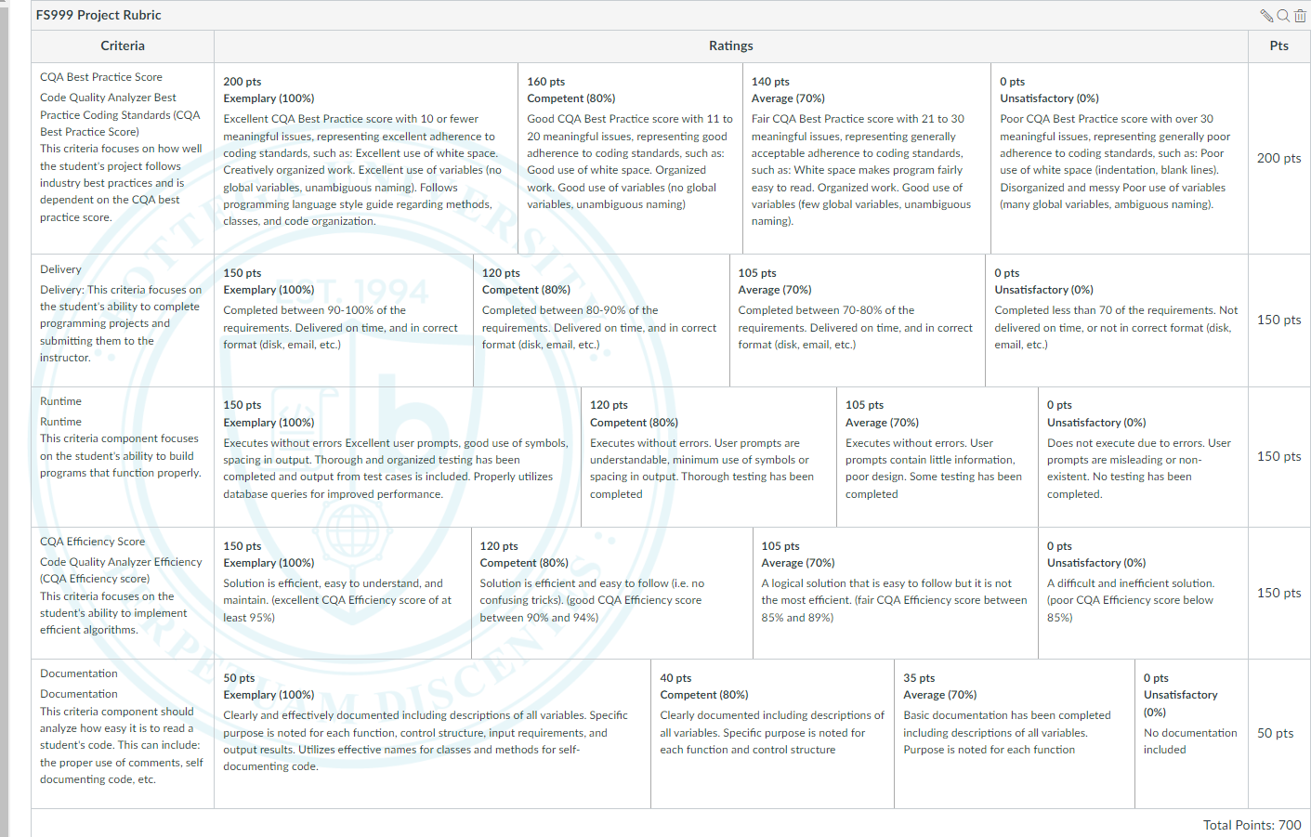

Grade Sheet:

**Grade Sheet to be Uploaded with Rubric to devCamp**

**Student’s Name_________________________________**

**Criteria 1:_______/200**

**Criteria 2:_______/150**

**Criteria 3:_______/150**

**Criteria 4:_______/150**

**Criteria 5:_______/50**

**Final total: ______/700**

**Final Grade from Rubric___________________________**

**Suggestions for improvement (be very detailed) Good bad ugly**

**________________________________________________________________________________________________________________________________________________________________________________________________________________________________________________________________________________________________________________________**

**Date ________________**

**Teaching Assistant or Instructor Name _______________________________________**

**Upload in devCamp and send to student.**